Estimated $ Per student Fix Value: 55$
District Goal: 95%
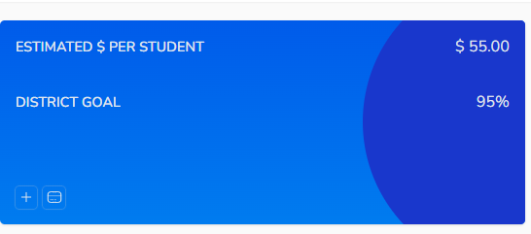

ESTIMATED $ MISSED ANNUALLY
Till Date jo be result ha us par nikla ga

Weekly ADA
Total Student count from Student Data table
Missed Students Count:
Sum all the campuses last 5 days of absents
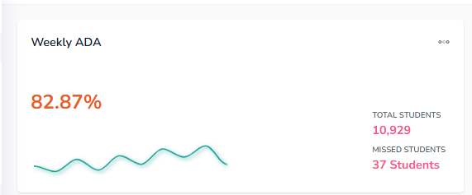
Total ADA
